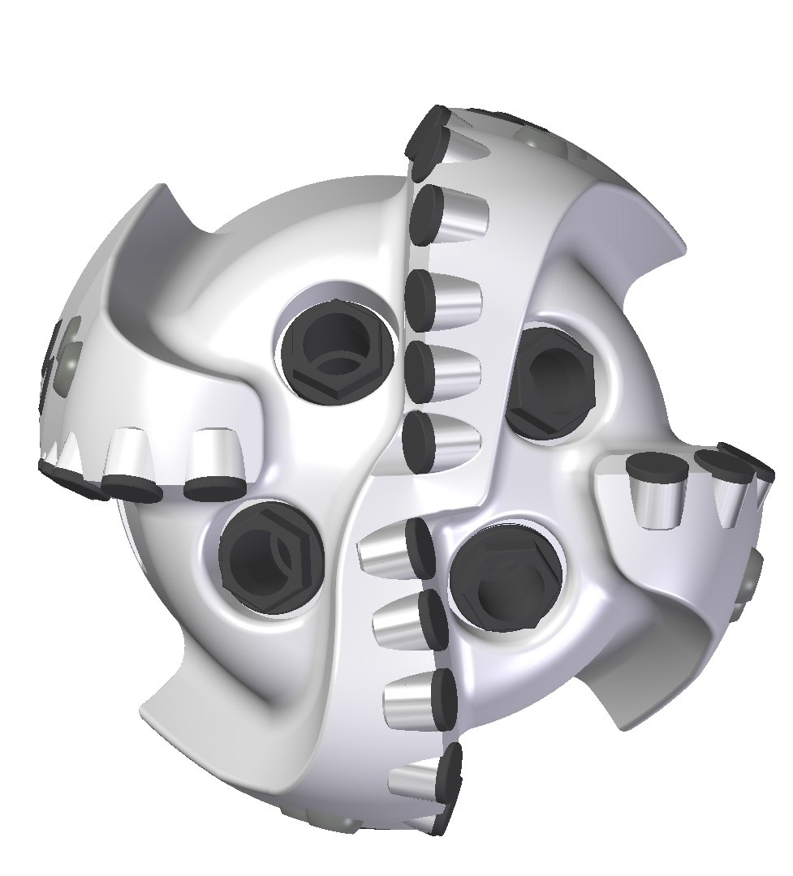 |  | 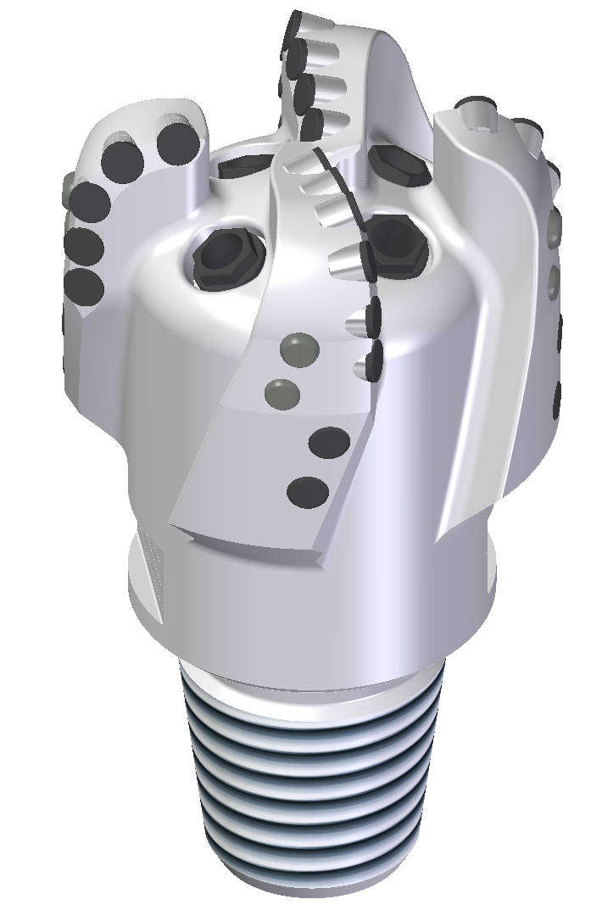

Drill Bit Specifications:
Cutter Size (Primary, Sec.) | 1/2”
Cutter Count (Total, Gage) | 23,7
Blade Count | 4
Gage Length (Inches) | 2.00
Nozzle Count (Primary, Sec.) | 4
Nozzle Series (Primary, Sec.) | 60
JSA (Sq. Inches) | 7.80
Max. TFA (Sq. Inches) | 0.99
Operating Parameters:
Max. Hydraulic Flow Rate (GPM) | 345
Max. Weight on Bit (1,000 Lbs.) | 20
Make-up Torque (ft/lbs) | 7611
Nominal Dimensions:
Overall Length (Inches) | 10.95
Make Up Length (Inches) | 7.20
Bit Breaker | SKB-21012
Connection | Ø3-1/2" API Reg.
Approx. Weight (Lbs.) | 45

Standard Features:

- Large open face volume assists cuttings removal
- Four nozzles optimize blade cleaning and cuttings removal
- Premium grade cutters maximize ROP and Life

413-SR(K) Nomenclature Explained:

- 4 = Number of Blades
- 13 = Primary Cutter Size (13mm)
- SR = Single Row Cutters
- K = Bullets

